### APPLIED ENGINEERING EDUCATION

Students enrolled in the 2021 curriculum have the option to take **Applied Engineering Education (AEE)** and a **graduation project** as alternatives to the courses in the 8th semester.

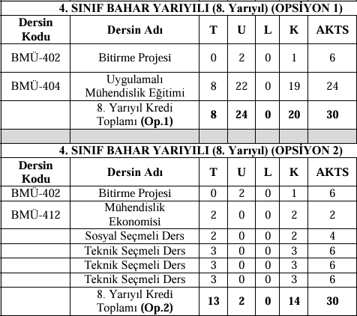

### APPLIED ENGINEERING EDUCATION GUIDELINES

The AEE directive has been published by the Faculty Dean's Office and can be accessed at <https://muhendislikf.firat.edu.tr/tr/page/10514>. Students wishing to enroll in this course must independently secure a workplace for their training.

#### General Requirements for AEE Applicants:

* Students must not have any incomplete or unattempted courses from semesters prior to the 8th semester due to absenteeism.
* Students may have at most **two courses with an FF grade** from previous semesters, provided they can graduate by taking these courses in make-up exams.
* A cumulative GPA of at least **2.50** by the end of the 7th semester is required.
* The selected workplace must employ at least **two computer engineers** and have a minimum of **20 personnel**.
* Students are required to **physically attend the workplace**; remote work will not be accepted.

Students who meet the above requirements or are likely to meet them by the end of the 7th semester can submit a pre-application through the form provided below. Pre-applications are limited to **10 students from the regular program** and **10 from the evening program**. Final eligibility will be determined after the 7th semester grades are finalized, based on cumulative GPA rankings.

#### Pre-Application Process:

Eligible students must obtain preliminary approval from their chosen workplace and submit the approval document along with the online form by **February 10, 2025**. The preliminary approval form template is available within the application form: <https://forms.gle/Dj3Vzaw5DEi7oyNd8>.

**Note:** Applications submitted to the department are considered preliminary. The application will only be deemed valid once the workplace approval letter is submitted to the department and approved by the Department Chair and the AEE Committee.